0

In Light Orange colour – in place of green - words in Green Bold

**Grab The SALE!** Subscribe for Product updates and Promotional **OFFERS!**

**CARE WITH NATURE – Go Natural**

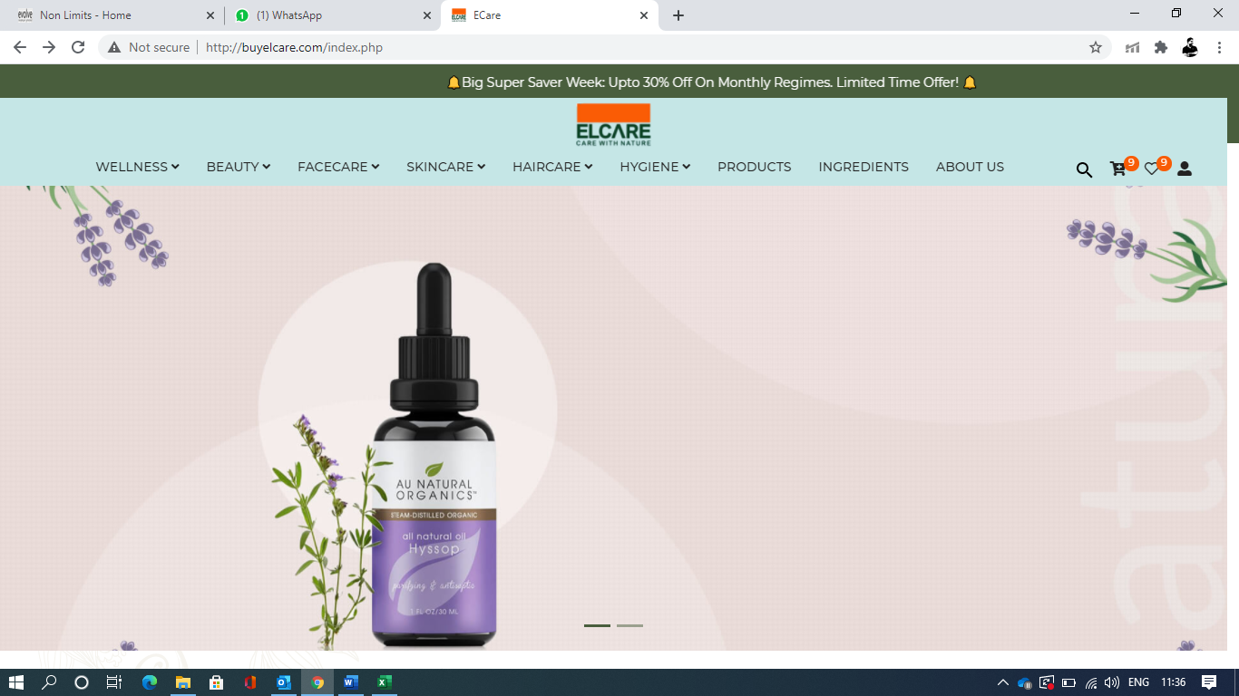

1

Wellness Beauty Face Care Skincare Hair Care Hygiene Accessories Ingrediants Products

Essential Oil Eyebrow and lAshes Serum Professional C Serum Scalp Revival Hair Sserum Rose quartz beauty roller

Lip and Undereye Serum Balancing Antioxidant Serum Jade Ritual protective roller

5 in 1 Nail Serum

BLOG ABOUT

Our Mission

Phylosophy

Team

Elcare’s Story

Values

News Room

**NO Automatic drop down for About Us – products – Blog – Ingrediants**

For Ingrediants – ( it will open a page with name of ingrediants and images)

For Productss – ( it will open a page with name of products and images with sorting option)

Blog – It will open up our Blog Page – Go Natural for Radiant Skin

NOTE: 1. ELCARE logo should be clear and CDR file to be used and a bit bigger in size (its our logo)

2. we don’t want arrow with headers

3. search box should be small and right of the search logo

2. when we click on few headers it will open with an Image and 2-3 words mentioned below the displayed images

Box size should be limited to product name and image.

**The words below header images will be**

Wellness Image Beauty Image Face Care Hair Care

**Calm Mind & Body** **Natural Glow** **Balancing Antiageing Protecting** **Nourishing Revitalising Restoring**

Accessories Skincare Hygiene

**Care With Nature For Raiant Skin Protective Care**

**NOTE: Colour will be White and all headers will be In Dark Green**

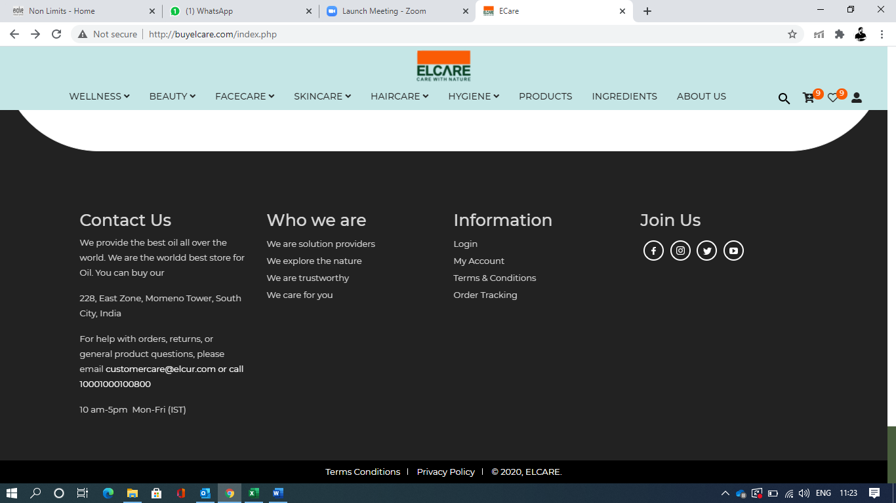

2 Background will Be white and with 6 frames with Shop Now Tab in Orange. **No animation and automatic flicking**

1. **Serums** – image of balancing antioxidant face serum and write - Organic Skincare Concept (shop now tab will be in Orange)
2. **Essential Oils** – Calm Mind and Body – images of all essential oil with name – Lemongrass – Rosemary – Tea Tree (shop now tab will be in Green)
3. **Accessories** – Natural Protection & Beauty – Images of Jade and rose rollers (shop now tab will be in Green)
4. **Combo** – Customer Favourite Pairs (Image of Professional C Serum + Scalp revival hair Serum) (shop now tab will be in Orange)
5. **Go Natural Blog** – Image of ELCARE and write CARE WITH NATURE for Radiant Skin (Subscribe tab will be in Green)
6. **Ingredients** – Images of key herbs and mountains and write Organic and Natural (shop now tab will be in Green)

Note: all 6 frames will be sperate and header will be at the top in BOLD and formate will be like half portion image and half portion message and in middle - top header name in ORNAGE and Bold.

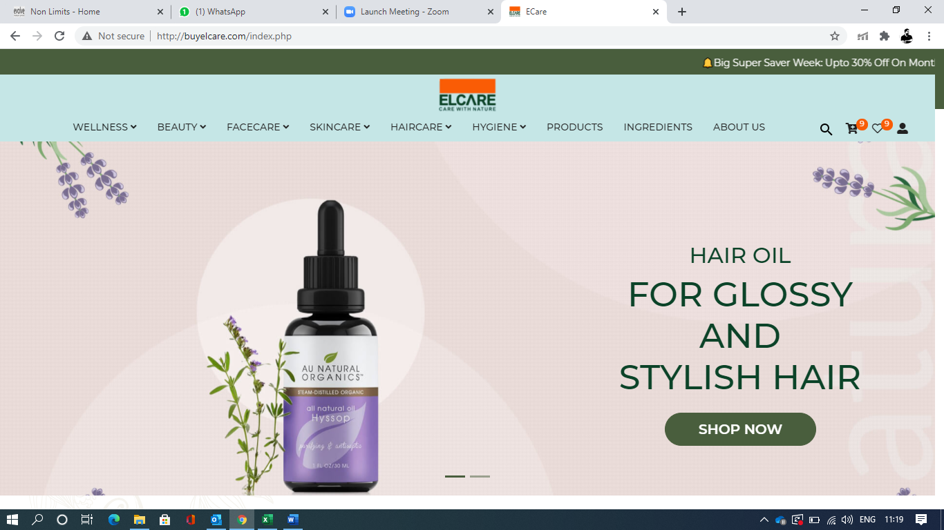

Below this image add only logos in green colour of 1. Dermatologically certified 2. GMO free 3. Handmade in india 4. No synthetic fragrance 5. No petrochemicals 6. No colours added 7. Freshly made 8. No sulfates 9. No parabens 10. ISO 11. Kosher 12. Organic 13. WHO GMP 14. 100% natural 15. FDA

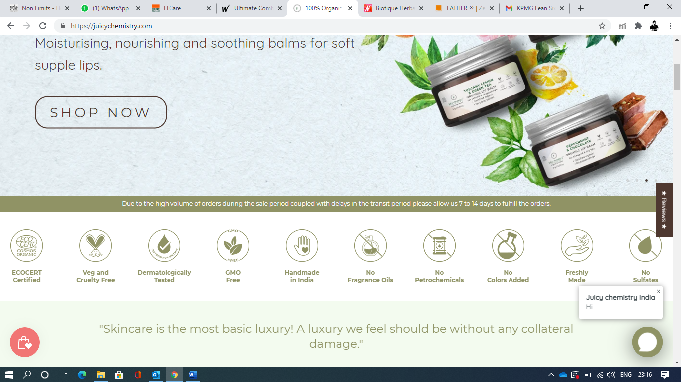

3 remove designs around ELcare and pages - ELCARE

Below ELcare –

Write : CARE WITH NATURE (in orange)

Video will be of elcare products and theme video (video frame should not be over lapped and should be same size)

1. **100% Natural**

Completely free of all harmful toxins. Made with only the highest quality ingredients. purely vegan and cruelty-free.

1. **Traditional Method**

Formulating modern beauty solutions from traditional beliefs Confirming the safety and quality of our products.

1. **No Synthetic fragrance**

we use naturally derived fragrance and flavor materials free of phthalates, parabens, and petrochemicals.

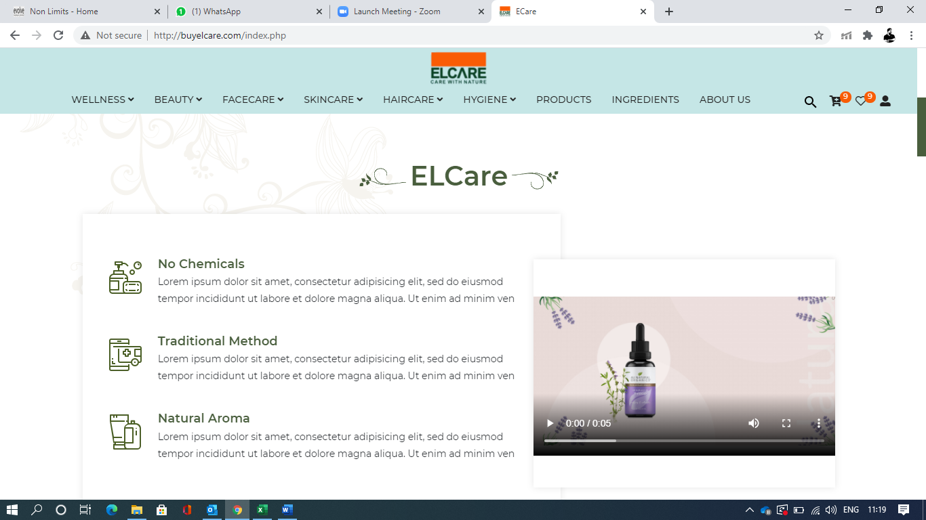

Frame should be with orange outline

4 SOLUTIONS

1. side scroller in white colour
2. write under Solutions – NATURAL ADVANCED EFFECTIVE
3. only 5 headers name : Wellness – Beauty – Facecare- Haircare – Accessories

front image Shop Now in Orange

1. Flip image: background should be in Orange and shop now in Green

Message on flip image:

Wellness: **Keep Calm!** Mind & Body

Beauty: **Natural Care!** That Feels Good

Face Care: A natural Confident **GLOW!**

Haircare: Natural Advanced Formulation to **SHINE ON!**

Accessories: Discover beauty for **Radiant Skin!**

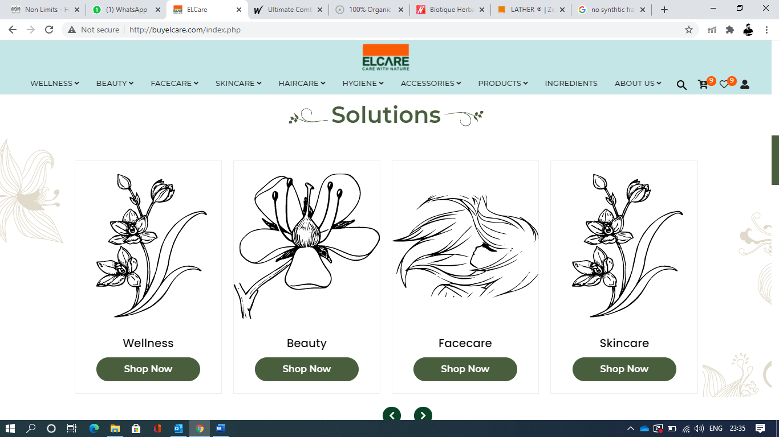

Arrow to be in orange and box should not come

5 remove graphics – BEST SELLER

1. Write below best seller: Customers Favourite Pick
2. Tabs: Favourites – Popular - New Products
3. Image should not be bigger than the frame when we take cursor above it.
4. Cart and Wishlist quick view box should be smaller

In Orange

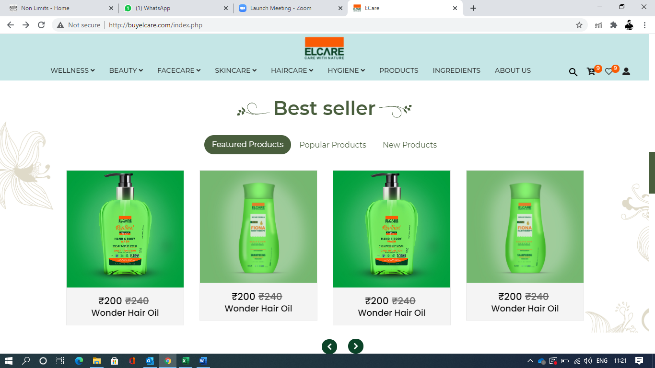

Arrow to be in orange and box should not come

7

1.Testimonial replaced by – FROM OUR COMMUNITY

Write below that : Synthetic Free Radiant Life

2. in Place of client 1 or client 2 : we will show only Star ratings like *****

3. This page will be in light orange with Dark green frame Border.

4. Background image will of ELCARE Product.

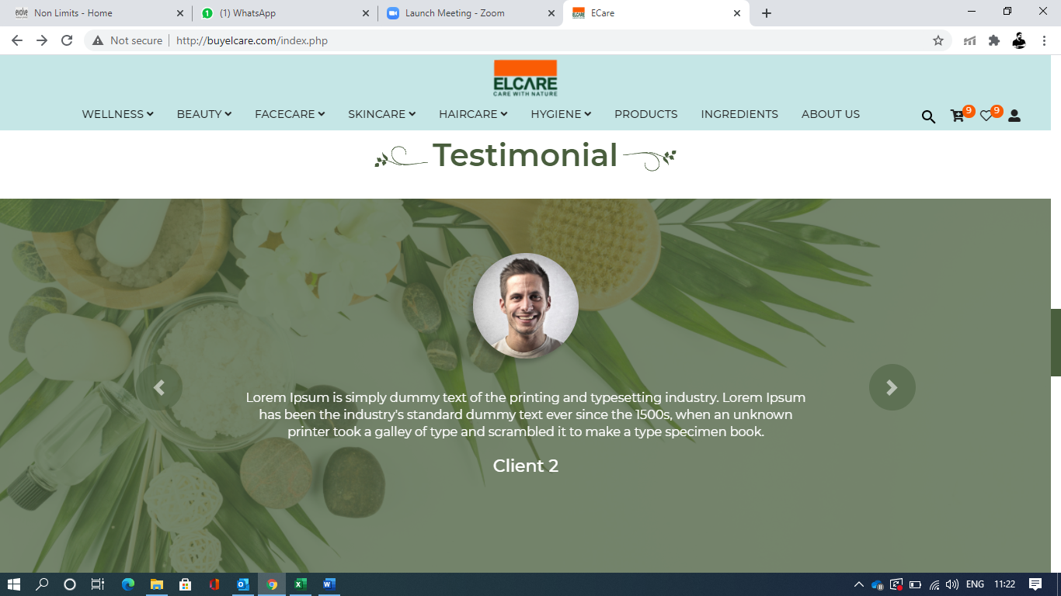

8

in Place of Natural Blog write : THE ELCARE EDIT

Below that write: GO NATURAL! For Radiant Skin

Remove graphics in page

Mention at least name and images of 3 blogs ( 2 on top and 1 below the both)

Blog heading

1. Go Natural
2. Balancing Antioxidant Face Serum
3. Professional C Serum

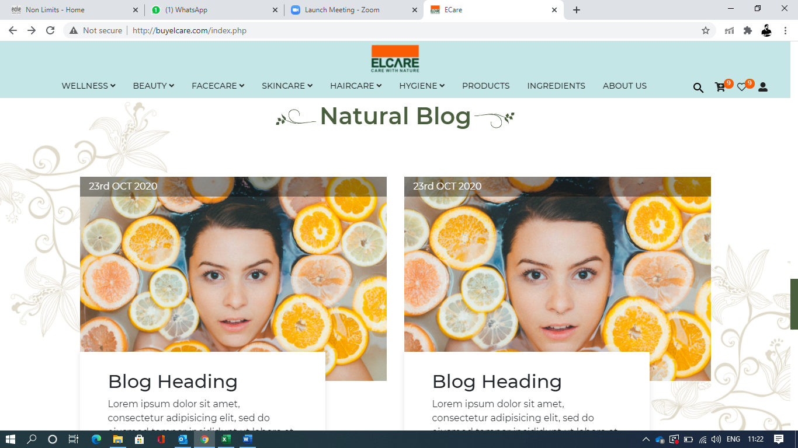

9

Certificates logo

1. Dermatologically certified

2. ISO

3. Kosher

4. Organic

5. WHO GMP

6. FDA

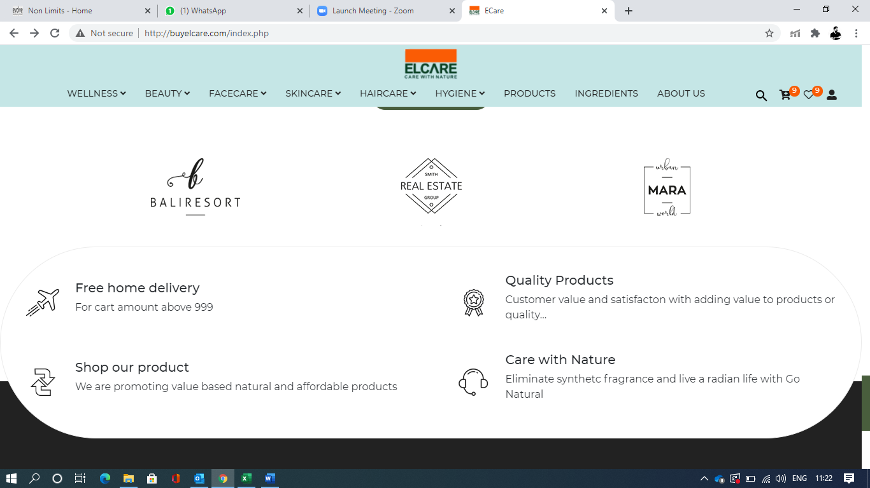

10

header in green and rest in orange

Free Home Delivery: For Purchase Amount Above 1500 INR

Quality Products: Customer Value and Satisfacton With Added Value To Products

(Logo will be trolley )Shop Our Product: We Are Promoting Value Based Natural And Affordable Products

(logo will be leaf with drop of water) Care With Nature: Eliminate Synthetc Fragrance And Live A Radiant Life With ELCARE



10

Black colour should be replaced by – Orange

Words in Green

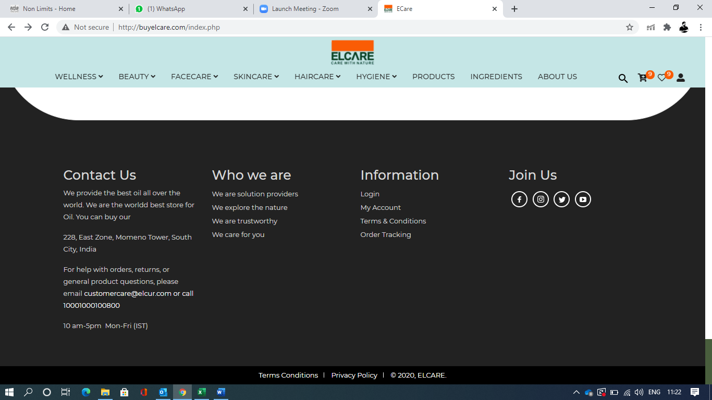

**QUICK LINK INFORMATON ACCOUNT**

Who We Are Contact Us Login NEED HELP?

ELCare’s Story Careers My Account Reach out us at care@elcur.in

All Products Shipping + Returns Order Tracking

|  |
| --- |
| **STAY in the know** |
| Sign up for exclusive offers, event details and skincare tips to help you feel real. |
| |  | | --- | |  | |

GO Natural BlogPolicy

FAQ

Enter E-Mail Address

Terms & Conditions I Privacy Policy I © 2020, ELCARE.



**Careers:** At present we don’t have any openings. You may drop your resume at [maya@elcur.in](mailto:maya@elcur.in) we will keep it in our data base and will contact you is there will be any suitable position open.

Contact Us:

## Customer Care

For help with orders, returns, or general product questions, please email [care@](mailto:care@)**elcur.in**

or call

[1800-120-](tel:1-877-652-8437)1111

10 am-5pm  Mon-Fri (IST)

**IMPORTANT**

* Responses can be delayed due to COVID-19 manpower restrictions. Please be rest Assured we will respond to you as soon as possible.
* We dispatch from multiple warehouses, thus you may receive multiple shipments. Please be rest assured you will receive all shipments.
* Our current delivery times are 7-10 working days due to COVID-19 restrictions.

For any queries, grievances, or feedback kindly email us at care@elcur.in. Please note responses can be delayed.

﻿Contact details for ELCUR PRIVATE LIMITED (ELCARE)

**Registered Address:** ELCUR PRIVET LIMITED #401,B Wing, DHARMODAYA BUILDING, 4th Floor, SECTOR 14, KOPARKHAIRANE, NAVI MUMBAI, MAHARASHTRA 400709 - India

**Toll Free Number:**1800-120-1111 **Working Hours** - (10AM - 4PM IST Monday to Friday)

Email Address: care@elcur.in